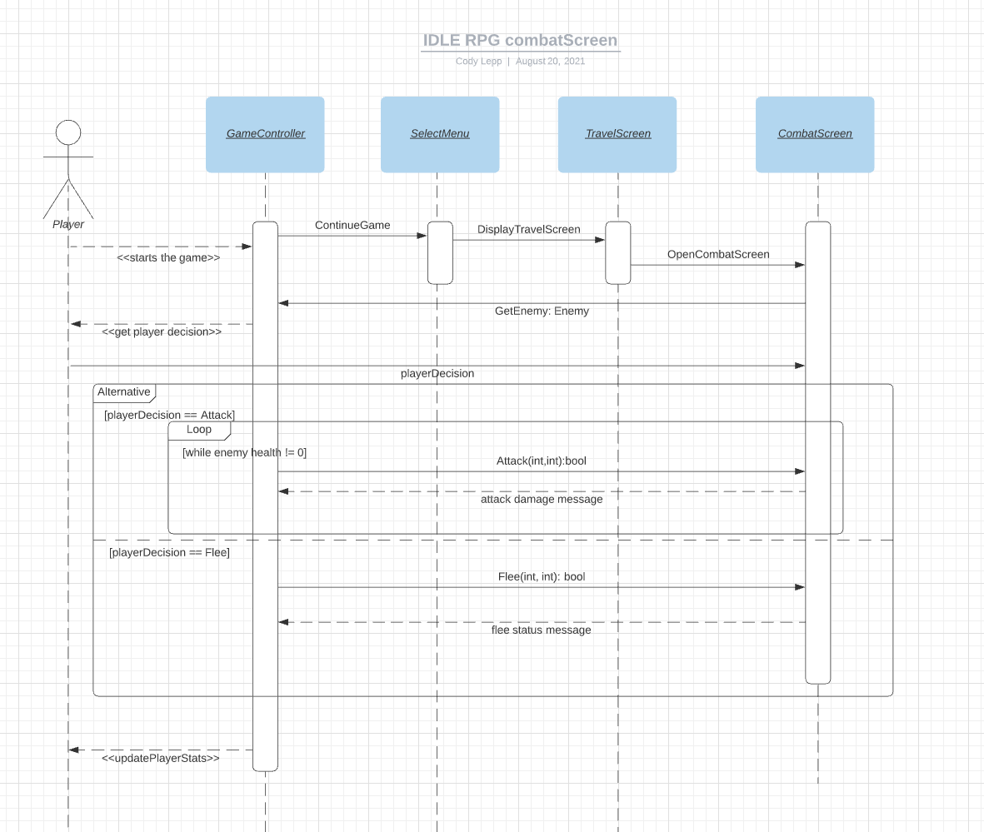

https://lucid.app/lucidchart/invitations/accept/inv_0f1cf682-9d54-47a2-aa3a-48b0385b8a67?viewport_loc=-348%2C-37%2C3072%2C1512%2C0_0